**EX-1. Write a java program to perform string methods by considering the given string inputs**

**PROGRAM**

import java.util.*;  
public class Assignment4_1 {  
 public static void main(String[] args){  
 String s1,s2;  
 s1 = "Welcome to Java";  
 s2 = s1;  
 String s3 = new String("Welcome to Java");  
 String s4 = s1.intern();  
 System.*out*.println(s1 == s2);  
 System.*out*.println(s2 == s3);  
 System.*out*.println(s1.equalsIgnoreCase(s2));  
 System.*out*.println(s2.compareTo(s2));  
 System.*out*.println(s1.equals(s2));  
 System.*out*.println(s2 == s4);  
 System.*out*.println(s1 + s2);  
 System.*out*.println(s1.charAt(0));  
 System.*out*.println(s1.indexOf('J'));  
 System.*out*.println(s1.indexOf("to"));  
 System.*out*.println(s1.lastIndexOf('a'));  
 System.*out*.println(s1.lastIndexOf("o", 15));  
 System.*out*.println(s1.codePointCount(0, s1.length()));  
 System.*out*.println(s1.length());  
 System.*out*.println(s1.substring(3));  
 System.*out*.println(s1.substring(1,3));  
 System.*out*.println(s1.startsWith("Wel"));  
 System.*out*.println(s1.endsWith("Java"));  
 System.*out*.println(s1.toLowerCase());  
 System.*out*.println(s1.toUpperCase());  
 System.*out*.println(" Hi".trim());  
 System.*out*.println(s1.replace('o', 'O'));  
 System.*out*.println(s1.replaceAll("o", "O"));  
 System.*out*.println(s1.replaceFirst("O", "o"));  
 System.*out*.println(s1.split("O"));  
 System.*out*.println(s1.split("O",4));  
 System.*out*.println(s1.codePointAt(0));  
 System.*out*.println(s1.contains("or"));  
 System.*out*.println(String.*join*("-", s1, s2, s3));  
 }  
}

**OUTPUT**

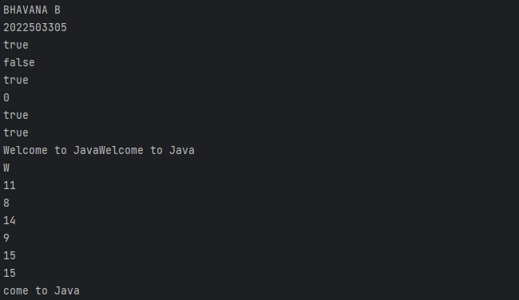

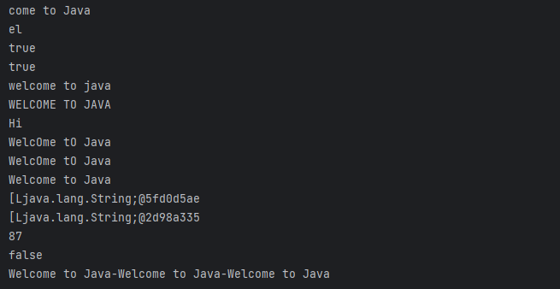

**EX-2. WRITE A JAVA PROGRAM TO READ THE STRING AND DISPLAYS THE REVERSE OF THE STRING.**

**PROGRAM**

import java.util.*;  
public class Assignment4_2 {  
 public static void main(String[] args) {  
 Scanner scan = new Scanner(System.*in*);  
 String statement;  
 System.*out*.println("BHAVANA\n2022503305");  
 System.*out*.println("Enter the String: ");  
 statement = scan.nextLine();  
 System.*out*.println("After the String reversed: ");  
 for (int i = statement.length(); i> 0; --i) {  
 System.*out*.print(statement.charAt(i-1));  
 }  
 }  
}

**OUTPUT**

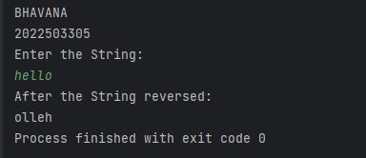

**EX-3 WRITE A JAVA PROGRAM TO COUNT THE NUMBER OF OCCURRENCE OF THE EACH LETTER IN THE GIVEN STRING USING SINGLE ARRAY**

**PROGRAM**

import java.util.*;  
public class Assignment4_3 {  
 public static void main(String[] args) {  
 Scanner scan = new Scanner(System.*in*);  
 System.*out*.println("BHAVANA B\n2022503305");  
 System.*out*.println("Enter the String: ");  
 String s;  
 int length;  
 s = scan.nextLine();  
 length = s.length();  
 int counter[] = new int[256];  
 for (int i = 0; i < length; i++){  
 counter [(int) s.charAt(i)]++;  
 }  
 for (int i = 0; i < 256; i++) {  
 if (counter[i] != 0) {  
 System.*out*.println((char)i + "--->" +counter[i]);  
 }  
 }  
 }  
}

**OUTPUT**

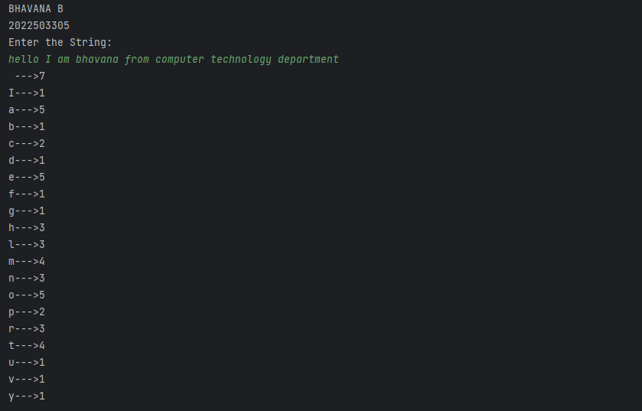

**EX-4 WRITE A JAVA PROGRAM THAT EXTRACTS ALL NUMBERS FROM A GIVEN STRING AND RETURNS THEM AS A NEW STRING.**

**PROGRAM**

import java.util.*;  
public class Assignment4_4 {  
 public static void main (String[] args){  
 Scanner scan = new Scanner(System.*in*);  
 System.*out*.println("BHAVANA B\n2022503305");  
 System.*out*.println("Enter the String: ");  
 String s,number;  
 s = scan.nextLine();  
 number = s.replaceAll("[^0-9]", "");  
 System.*out*.println(number);  
 }  
}

**OUTPUT**

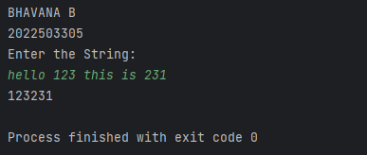

**EX-5. WRITE A JAVA PROGRAM THAT PERFORMS STRING COMPRESSION USING THE COUNTS OF REPEATED CHARACTERS.**

**PROGRAM**

import java.util.*;  
public class Assignment4_5 {  
 public static String compression(String s){  
 StringBuffer sb = new StringBuffer();  
 int count = 1;  
 char previous = s.charAt(0);  
 for(int i = 0; i< s.length(); i++){  
 char current = s.charAt(i);  
 if (previous == current) {  
 count++;  
 }  
 else {  
 sb.append(previous);  
 sb.append(count);  
 previous = current;  
 count=1;  
 }  
 }  
 sb.append(previous);  
 sb.append(count);  
 if(s.length() < sb.length()) {  
 return s;  
 }  
 else {  
 return sb.toString();  
 }  
 }  
 public static void main(String[] args){  
 System.*out*.println("BHAVANA B\n2022503305");  
 Scanner scan = new Scanner(System.*in*);  
 String s;  
 System.*out*.println("Enter the String: ");  
 s = scan.nextLine();  
 System.*out*.println("After Compression: "+*compression*(s));  
 }  
}

**OUTPUT**

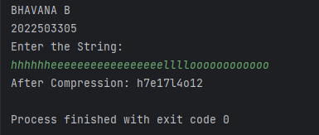

**EX-6. WRITE A JAVA PROGRAM TO CHECK THE GIVEN STRING IS ANAGRAM OR NOT**

**PROGRAM**

import java.util.*;  
public class Assignment4_6 {  
 public static void main(String[] args) {  
 System.*out*.println("BHAVANA B\n2022503305");  
 Scanner scan = new Scanner(System.*in*);  
 System.*out*.println("Enter the First String: ");  
 String s1, s2;  
 s1 = scan.nextLine();  
 System.*out*.println("Enter the Second String: ");  
 s2 = scan.nextLine();  
 boolean status;  
 if (s1.length() != s2.length()) {  
 status = false;  
 System.*out*.println("Not an Anagram");  
 }  
 else {  
 char[] Array1 = s1.toLowerCase().toCharArray();  
 char[] Array2 = s2.toLowerCase().toCharArray();  
 Arrays.*sort*(Array1);  
 Arrays.*sort*(Array2);  
 status = Arrays.*equals*(Array1, Array2);  
 if (status == true) {  
 System.*out*.println(s1 +" and "+s2+" are Anagram");  
 }  
 else{  
 System.*out*.println("Not an Anagram");  
 }  
 }  
 }  
}

**OUTPUT**

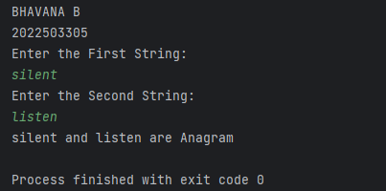

**EX-7**

**PROGRAM**

import java.util.Scanner;  
public class Assignment4_7 {  
 public static void main(String[] args) {  
 Scanner scanner = new Scanner(System.*in*);  
 System.*out*.println("BHAVANA B\n2022503305");  
 System.*out*.print("Enter the first string: ");  
 String str1 = scanner.nextLine();  
 System.*out*.print("Enter the second string: ");  
 String str2 = scanner.nextLine();  
 String[] parts1 = str1.split("\\.");  
 String[] parts2 = str2.split("\\.");  
 for (int i = 0; i < parts1.length; i++) {  
 int num1 = Integer.*parseInt*(parts1[i]);  
 int num2 = Integer.*parseInt*(parts2[i]);  
 if (num1 > num2) {  
 System.*out*.println(str1 + " is greater than " + str2);  
 return;  
 } else if (num1 < num2) {  
 System.*out*.println(str2 + " is greater than " + str1);  
 return;  
 }  
 }  
 System.*out*.println(str1 + " is equal to " + str2);  
 }  
}

**OUTPUT**

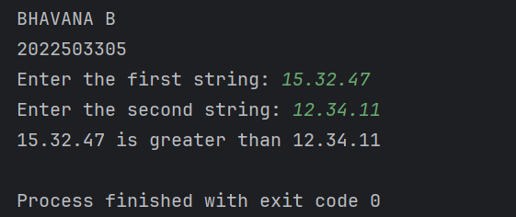

**EX-8. WRITE A JAVA PROGRAM TO COMPARE THE EMAIL IS VALID IS INVALID AND RETRUNS THE USERNAME AND DOMAIN NAME**

**PROGRAM**

import java.util.Scanner;  
public class Assignment4_8 {  
 public static void main(String[] args) {  
 System.*out*.println("BHAVANA B\n2022503305");  
 Scanner scanner = new Scanner(System.*in*);  
 System.*out*.print("Enter the email address: ");  
 String email = scanner.nextLine();  
 if (*isValidEmail*(email)) {  
 String[] parts = email.split("@");  
 String username = parts[0];  
 String domain = parts[1];  
 System.*out*.println("Valid Email");  
 System.*out*.println("Username: " + username);  
 System.*out*.println("Domain: " + domain);  
 } else {  
 System.*out*.println("Invalid Email");  
 }  
 }  
 public static boolean isValidEmail(String email) {  
 int atIndex = email.indexOf('@');  
 if (atIndex == -1 || atIndex != email.lastIndexOf('@')) {  
 return false;  
 }  
 String username = email.substring(0, atIndex);  
 String domain = email.substring(atIndex + 1);  
 if (username.length() == 0 || username.length() > 25) {  
 return false;  
 }  
 for (char c : username.toCharArray()) {  
 if (!Character.*isLetterOrDigit*(c) && c != '_' && c != '-' && c != '+') {  
 return false;  
 }  
 }  
 if (!domain.endsWith(".com") && !domain.endsWith(".in") && !domain.endsWith(".edu")) {  
 return false;  
 }  
 return true;  
 }  
}

**OUTPUT**

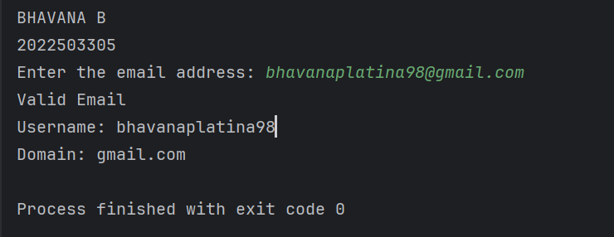

**EX-9 WRITE A JAVA PROGRAM TO CREATE A DICTIONARY USING 2D STRING ARRAY ANY 10 PROGRAMMING LANGUAGES. WRITE A METHOD THAT RETURN THE DEFINITION FOR THE INPUT OF PL NAME.**

**PROGRAM**

import java.util.Scanner;  
public class Assignment4_9 {  
 public static void main(String[] args) {  
 System.*out*.println("BHAVANA B\n2022503305");  
 String[][] dictionary = {  
 {"Java", "Pure object-oriented programming language by James Gosling"},  
 {"C++", "Object-oriented programming language by Bjarne Stroustrup"},  
 {"Python", "High-level programming language with dynamic typing by Guido van Rossum"},  
 {"JavaScript", "Scripting language primarily used for web development"},  
 {"C", "Procedural programming language by Dennis Ritchie"},  
 {"Ruby", "Dynamic, reflective, object-oriented programming language by Yukihiro Matsumoto"},  
 {"Swift", "Programming language for iOS and macOS apps by Apple"},  
 {"Go", "Statically typed programming language designed at Google by Robert Griesemer, Rob Pike, and Ken Thompson"},  
 {"Rust", "System programming language focused on safety and performance by Mozilla"},  
 {"Kotlin", "Statically typed programming language for modern multi-platform applications"}  
 };  
 Scanner scanner = new Scanner(System.*in*);  
 System.*out*.print("Enter the programming language name: ");  
 String language = scanner.nextLine();  
 String definition = *getDefinition*(dictionary, language);  
 if (definition != null) {  
 System.*out*.println(language + ": " + definition);  
 } else {  
 System.*out*.println("Definition not found for " + language);  
 }  
 }  
 public static String getDefinition(String[][] dictionary, String language) {  
 for (int i = 0; i < dictionary.length; i++) {  
 if (dictionary[i][0].equalsIgnoreCase(language)) {  
 return dictionary[i][1];  
 }  
 }  
 return null;  
 }  
}

**OUTPUT**

